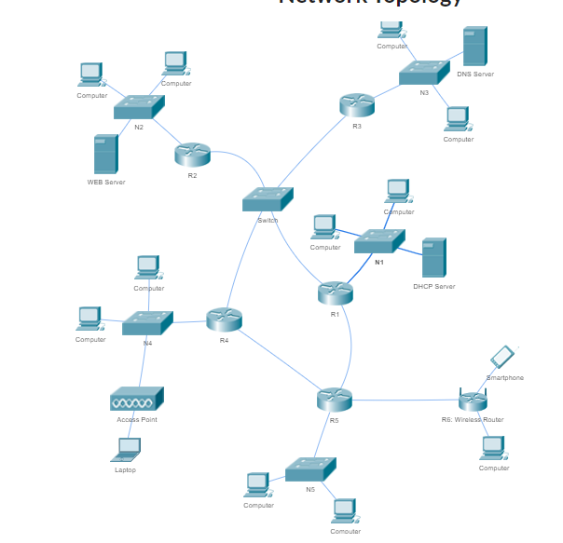

IP: 168.175.169.0, NetMask: 255.255.255.0 /24

N1: 40,

N2: 40,

N3: 20,

N4: 20,

N5: 4,

N1234: 4, N15:2, N45:2, N5w:2

=>N1: 40+3 = 43 < 64=2^6 /26

N2: 40+3 = 43 < 64=2^6 /26

N3: 20+3 = 23< 32 = 2^5 /27

N4: 20+3 = 23< 32 = 2^5 /27

N5: 4+3 = 7 <8 = 2^3 /29

N1234: 4+2 = 6 <8 = 2^3 /29

N15: 2+2 = 4< 4 = 2^2 /30

N45: 2+2 = 4< 4 = 2^2 /30

N5w: 2+2 = 4< 4 = 2^2 /30

64+64+32+32+8+8+4+4+4 = 220 <2^8 =256

[0-63][64-127][128-159][160-191][192-199][200-207][208-211][212-215][216-219][220-256]

n1 n2 n3 n4 n5 n1234 n15 n45 n5w

N1: 168.175.169.0 /26, R1=.1, Serverdhcp=.2 NM: .192

N2: 168.175.169.64 /26, R2=.65, S2web=.66, NM: .192

N3: 168.175.169.128 /27, R3=.129, S3dns=.130, NM: .224

N4: 168.175.169.160 /27, R4=.161, NM: .224

N5: 168.175.169.192 /29, R5=.193, NM: .248

N1234: 168.175.169.200 /30, R1=.201, R2=.202, R3=.203, R4=.204, NM: .252

N15: 168.175.169.208 /30, R1=.209, R5=.210, NM: .252

N45: 168.175.169.212 /30, R4=.213, R5=.214, NM: .252

N5w: 168.175.169. 216 /30, R5=.217, Rw=.218, NM: .252